Chapter 11
Hub Specification

This chapter describes the architectural requirements for the USB hub. It contains a description of the two principal sub-blocks: the hub repeater and the hub controller. The chapter also describes the hubs operation for error recovery, reset, and suspend/resume. The second half of the chapter defines hub request behavior and hub descriptors.
The hub specification supplies sufficient information to permit an implementer to design a USB hub which conforms to the USB specification.

Overview
Hubs provide the electrical interface between USB devices and the host and are directly responsible for supporting many of the attributes that make USB user friendly and hide its complexity from the user. Listed below are the major aspects of USB functionality that hubs must support:
- Connectivity behavior
- Power management
- Device connect/disconnect detection
- Bus fault detection and recovery
- Full/Low speed device support
A hub consists of two components, the hub repeater and the hub controller. The repeater is responsible for connectivity setup and tear-down. It also supports exception handling such as bus fault detection and recovery and connect/disconnect detect. The hub controller provides the mechanism for host to hub communication. Hub specific status and control commands permit the host to configure a hub and to monitor and control its individual downstream ports.

Device Characteristics

Hub Architecture
Figure 11-1 shows a hub and the locations of its root and downstream ports. A hub consists of a repeater section and a hub controller section. The repeater is responsible for managing connectivity on a per packet basis, while the hub controller provides status and control and permits host access to the hub.
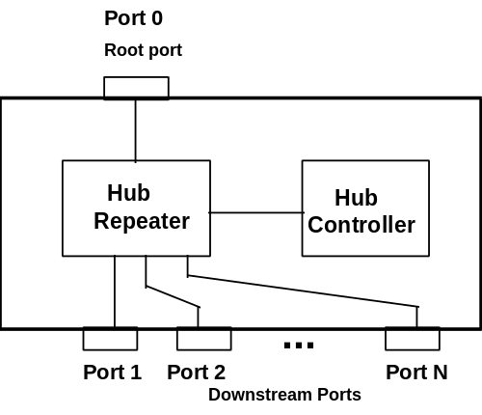
Figure 11-1. Hub Architecture

Hub Connectivity
Hubs display differing connectivity behavior depending on whether they are propagating packet traffic or resume signaling, or are in the idle state.

Packet Signaling Connectivity
The hub repeater contains one port that must always connect in the upstream direction (referred to as the root port) and one or more downstream ports. Upstream connectivity is defined as being towards the host, and downstream connectivity is defined as being towards a device. Figure 11-2 shows the packet signaling connectivity behavior for hubs in the upstream and downstream directions. A hub also has an idle state during which the hub makes no connectivity. When in the idle state all of the hub’s ports are in the receive mode waiting for the start of the next packet.
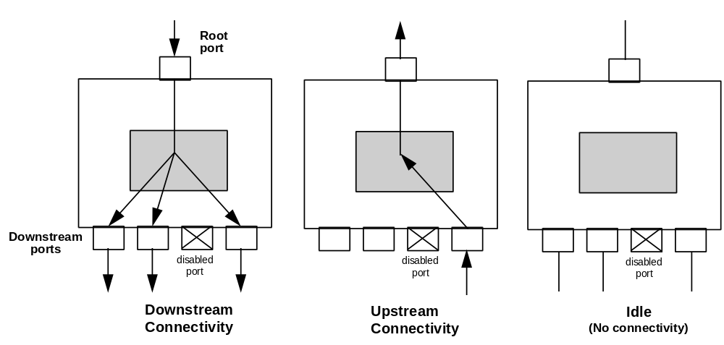
Figure 11-2. Hub Connectivity
If a downstream hub port is enabled (i.e., in a state where it can propagate signaling through the hub) and the hub detects an SOP on that port, connectivity is established in an upstream direction to the root port of that hub, but not to any other downstream ports. This means that when a device or a hub transmits a packet upstream, only those hubs in line between the transmitting device and the host will see the packet. When SOP on an upstream port is detected, all other downstream ports are locked. This guarantees that hub connectivity will not be modified until the next EOP is detected or until the hub times out at the end of the frame.
In the downstream direction, hubs operate in a broadcast mode. When a hub detects an SOP on its root port, it establishes connectivity to all enabled downstream ports. If a port is not enabled, it does not receive any packet traffic activity from the root port and does not propagate packet signaling downstream.

Resume Connectivity
Hubs exhibit differing connectivity behaviors for upstream and downstream directed resume signaling. A hub which is in the suspend state reflects resume signaling from its root port to all of its enabled downstream ports. Figure 11-3 illustrates hub upstream and downstream resume connectivity.
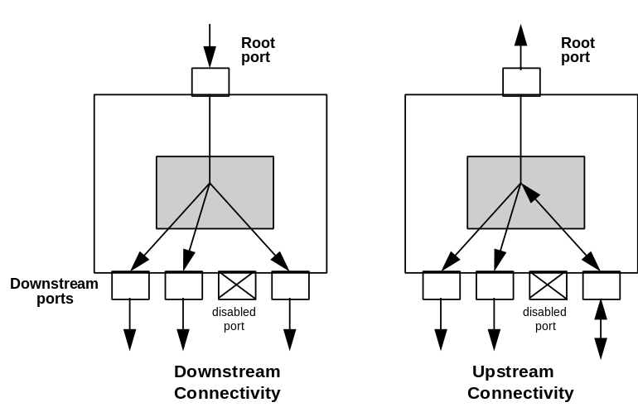
Figure 11-3. Resume Connectivity
If a hub is in the suspend state and detects resume signaling from a downstream port, the hub reflects that signaling upstream to its root and also to all of its enabled downstream ports, including the port which initiated the resume sequence. Resume signaling is not reflected to disabled ports. A detailed discussion of resume connectivity appears in Section 11.5

Hub Port States
A hub downstream port may be in one of four or five possible states and must comprehend such features as connect/disconnect detect, port enable/disable, suspend/resume, reset, and, optionally, power switching. Hubs must support independent port state machines on a per downstream port basis. Figure 11-4 illustrates the states for a non-power switched port, and Figure 11-5 shows the states for a port with power switching. Hub port states apply only to downstream ports.
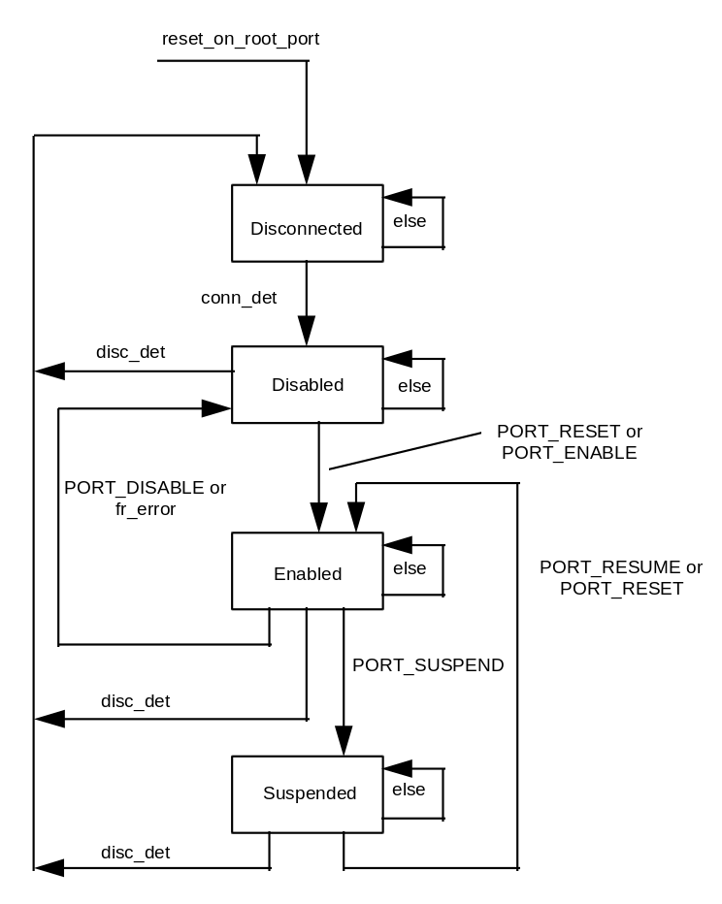
Figure 11-4. Non-power Switched Hub Port States
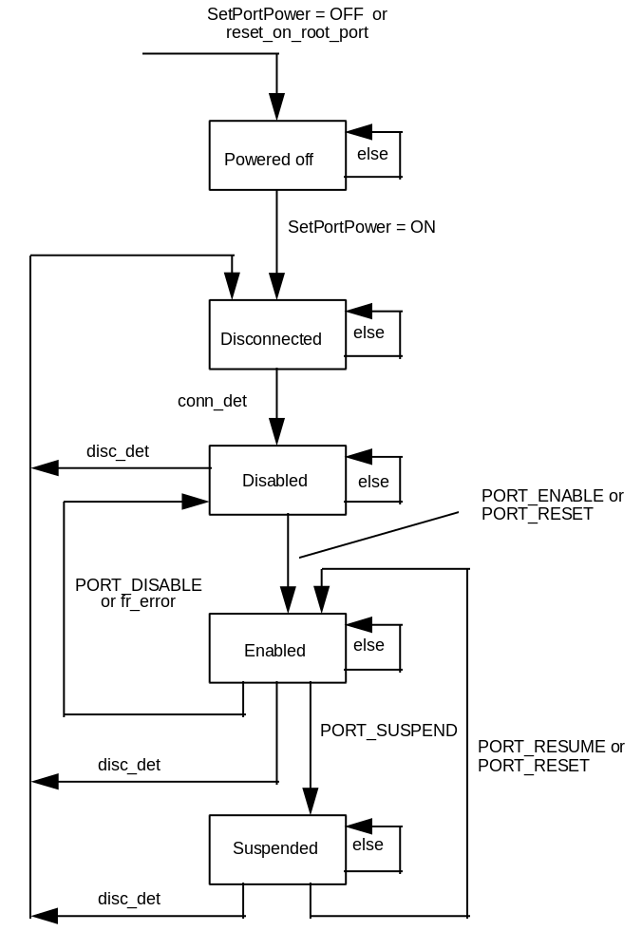
Figure 11-5. Power Switched Hub Port States
Each of the states is described below.
Powered off: This state is only supported for ports that have power switching as shown in Figure 11-5. A port transitions to its powered off state when the hub receives a ClearPortFeature(port_power) request, or when the hub detects root port reset signaling. A hub’s downstream ports also transition to the powered off state when power is initially applied to a hub. A powered off port supplies no power downstream, and its signal outputs buffers are placed in the Hi-Z state. A powered off port ignores all upstream directed bus activity on that port.
Disconnected: A downstream port of a hub supporting power switching transitions from the powered off to the disconnected state when power is applied to the port via a SetPortFeature(port_power) request. If a hub does not support power switching, it transitions to the disconnected state upon power up or upon receipt of a root port reset. In the disconnected state, a port cannot propagate any signaling in either the upstream or downstream direction. However, the port can detect a connect event (conn_det), which sets a status field in the hub controller and causes the port state to transition to the disabled state.
Conn_det is asserted if a downstream port is in the disconnect state and detects 2.5 μs of continuous non SE0 signaling on the bus. When conn_det is first asserted, the idle bus state can be driven from either a low or full speed device, and may be either a DIFF0 or a DIFF1. The hub automatically determines the device type (low or full speed) by determining whether D+ or D- is pulled high. Device speed determination is completed before the hub transitions to the disabled state.
Disabled: A port transitions to the disabled state from the disconnected state when it detects a connect event (conn_det). This requires that the port first be power switched on if the hub supports power switching. A port in the disabled state can only propagate downstream directed signaling arising from a SetPortFeature(reset) request; at all other times, the port’s output buffers are in the Hi-Z state. In the upstream direction, a port in the disabled state does not propagate any signaling through the hub to the root port when the hub is awake. However, certain events, such as disconnect will cause upstream resume signaling to be propagated to the root port if the hub is in the suspend state. A disconnect event (disc_det) will cause the port to return to the disconnect state and will set a status field in the hub controller. Disc_det is asserted whenever the port detects 2.5 μs of continuous SE0 when the port is not propagating downstream traffic. Before a disconnect event can be timed the hub suspended hub must first wake up.
Enabled: A port transitions to the enabled state upon receipt of a SetPortFeature(port_enable) or a SetPortFeature(port_reset) request. In the enabled state the port propagates all downstream signaling, full speed packet traffic and reset signaling; low speed packet traffic is propagated downstream when preceded by the preamble PID. In the enabled state, the port propagates all upstream signaling including full speed and low speed packets and resume signaling. A port transitions to the disabled state if it receives a ClearPortFeature(port_enable) request or if a frame error (fr_error) occurs. The ClearPortFeature(port_enable) request may be issued at any time by the host, and the hub must respond by immediately placing the port in the disabled state. An enabled port will transition to the disconnected state if a disconnect detect occurs.
Suspended: The hub selectively suspends all devices downstream of a port when it receives a SetPortFeature(port_suspend) request. This request must not cause the now suspended port to stop propagating in the middle of a transaction; i.e., the current transaction must complete before the port enters the suspend state. A port displays different suspend connectivity behavior depending on whether the hub is awake or is itself suspended. If the hub is awake, no upstream or downstream connectivity can propagate through the port. However, if the hub is suspended, an idle to resume or an idle to SE0 transition on the port is reflected onto all other non-disabled ports as an idle to resume transition. This behavior makes it possible to suspend multiple hubs in series and still have a device at the bottom be able to wake up the entire bus.
If a hub is suspended and bus activity occurs on a suspended port, the hub first wakes up. The termination of a resume request to the port causes a status field to be set in the hub. In response, the host polls the hub to read the status field change and determine which on which port the resume occurred. The hub port transitions to the enabled state when the resume is complete. Details of the hub port signaling for selective resume are described in Section 11.5.2.
A disconnect event to a suspended hub causes the hub state to transition to the disconnected state and sets the hub controller status field to indicate that a disconnect has occurred. It is not possible to place a disconnected port directly into the suspend mode, since the port never exits the disconnected state.
Table 11-1 summarizes hub port behavior in different port states for different types of signaling. Hub behavior during resume signaling when the hub itself is in the suspend state constitutes a special case, and is discussed in Section 11.5.2.1.
Table 11-1. Port Behavior vs. Signaling
Signaling\State | Powered-off | Disconnected | Disabled | Enabled | Suspended
Reset on root port (hub with power switching) | Stay in Powered-off | Go to Powered off | Go to Powered off | Go to Powered off | Go to Powered off
Reset on root port (hub without power switching) | N.A. | Go to Disconnected | Go to Disconnected | Go to Disconnected | Go to Disconnected
ClearPortFeature(port_power)(hub with power switching) | Stay in powered-off | Go to Powered off | Go to Powered off | Go to Powered off | Go to Powered off
SetPortFeature(port_power)(hub with power switching) | Go to Disconnected | N.A. | N.A. | N.A. | N.A.
SetPortFeature(port_reset) request | Stay in Powered -off | Go to Enabled | Go to Enabled | Stay in Enabled | Go to Enabled
SetPortFeature(port_enable) request | Ignore | Ignore | Go to Enabled | Stay in Enabled | Ignore
ClearPortFeature(port_enable) request | Ignore | Ignore | Stay at Disabled | Go to Disabled | Ignore
Downstream packet traffic (hub awake) | Do not propagate | Do not propagate | Do not propagate | Propagate traffic | Do not propagate
Upstream packet traffic (hub awake) | Do not propagate | Do not propagate | Do not propagate | Propagate traffic | Set status field, do not propagate
SetPortFeature(port_suspend)request | Ignore | Ignore | Ignore | Go to Suspend | Ignore
ClearPortFeature(port_suspend) request | Ignore | Ignore | Ignore | Ignore | Go to Resume
Disconnect detect | Ignore | Ignore | Go to Disconnected | Go to Disconnected | Go to Disconnected
Connect Event | Ignore | Go to Disabled | N.A. | N.A. | N.A.

Device Detach Detection
A hub is able to detect a detach event by means of a continuous SE0 persisting for at least 2.5 μs detected at a downstream port. In response to a detach event, the hub places the port into the Disconnected state and floats its output buffers to a Hi-Z. Device detach can only be detected while there is no downstream traffic on the bus. If power is removed from a port, it must respond by registering a detach event and placing the port in the Powered Off state. This guarantees if a device is detached and a new one added that the attach event will be acknowledged.

Bus State Evaluation
Bus state evaluation is done at the end of the frame and is able to discriminate between the SE0, the differential 1 and 0 bus states. When no device is connected to a downstream hub port, its pull-down resistors pull both D+ and D- below VSE(min).
Connect/Disconnect detect can only be performed after Vbus is applied to the downstream port. (This requirement only affects hubs whose downstream ports are power switched.) When a device is connected, the bus state changes from the disconnected to the attach detect state. Low speed devices pull up D- to an SE1 and leave D+ at SE0. Full speed devices pull up D+ to an SE1 and leave D- at SE0. Each downstream hub port must be capable of detecting and differentiating between low speed and full speed device connections once a device is connected. The differential J and K states are undefined until a device is attached and the device’s speed has been ascertained.
When a connect or disconnect occurs, it must be reflected in the hub status by the end of the frame in which the event occurred unless the hub is in the reset or suspend modes. A hub in the suspend mode is awakened by a connect or disconnect event and must be capable of reporting the event upon completion of resume. Upon coming out of reset, a hub must detect which downstream ports have devices connected to them. Connect and disconnect changes are reported on a per-port basis.

Full vs. Low Speed Behavior
Hubs must differentiate between full speed and low speed devices when a device is connected to the bus or at power-up. Hubs detect whether a device is full or low speed when the hub port transitions from its disconnected to its disabled state. Devices attached to a hub are determined to be either full speed or low speed by detecting which data line (D- or D+) is pulled high. Low speed devices pull D- high, and full speed devices pull D+ high. Full speed signaling must not be transmitted to low speed devices. Doing so could cause low speed devices to mistakenly respond to full speed signaling and create a bus conflict. Communication between the host and the hub controller are always done using full speed signaling.
If a device is detected to be low speed, the hub port’s output buffers are configured to operate at the slow slew rate (75-300 ns), and the port will not propagate downstream directed traffic unless it is prefaced with a preamble PID. Low speed signaling immediately follows the PID and is propagated to both low and full speed devices. Full speed devices will never misinterpret low speed traffic because no low speed data pattern can generate a valid full speed PID. When low speed signaling is enabled, a hub continues to propagate downstream signaling to all enabled ports until a downstream EOP is detected, at which time the output drivers for the low speed ports are turned off and will not be turned on again until the hub receives another PRE PID. If a port is disabled, no signaling is propagated to the port. Hubs must enable their low speed port drivers within four full speed bit times of having received the last bit of the PRE PID, and at that time they must drive a low speed J onto the bus.
If a downstream port is enabled, it propagates upstream directed bus signaling independently of whether the port was configured as low speed or full speed. Hubs implement slew rate selectable output buffers only in the downstream direction on their downstream ports; in the upstream direction, they transparently propagate both low and high speed traffic using fast (4-20 ns) edge rates. Low speed devices do not append a preamble onto their upstream traffic.
While propagating low speed traffic upstream, hubs must be able to respond to EOPs that are either two low speed bit times or two full speed bit times wide. The former will occur under normal operation in which the low speed device generates the EOP. The latter occurs if a downstream hub encounters an end of frame babble or LOA condition and generates an EOP upstream in response (refer to Section 11.4.5).

Low Speed Keep-Alive
All hub ports to which low speed devices are connected must generate a low speed keep-alive strobe, generated at the beginning of the frame, which consists of two low speed bit times of SE0 followed by at least 0.5 bit times of J state. Low speed devices use the strobe to prevent themselves from going into suspend in the absence of low speed bus traffic. The hub repeater generates the keep-alive from its internal SOF counter, and the keep-alive strobe must start no sooner than the second EOF point and must complete no later than the EOP of the token packet.
The low speed keep alive strobe must be generated once per frame, and it must track the SOF token such that the following rules are adhered to.
- When going into suspend, the keep-alive must not go away before the last SOF.
- A hub is allowed to synthesize no more than three keep alive strobes after receipt of the last SOF.
- Keep alive must occur no later than one frame after resumption of SOF.

Hub State Operation
The hub state operation is shown in Figure 11-6. Upon coming out of reset or power-up, a hub starts in the WFSOP state. The hub waits for a start of a packet (SOP) to be detected on its root port or any of its enabled downstream ports. If an SOP is detected, the hub establishes connectivity originating from the port on which the SOP occurred and transitions to its WFEOP state. It remains in this state until an end of packet (EOP) is encountered or until the end of frame (EOF) occurs. Under normal circumstances, and when not near the end of a frame, a hub repeater will transition back and forth between WFSOP and WFEOP.
A hub in the idle (WFSOP) state responds to the end of frame (EOF1) point by transitioning to the WFSOF state. If a hub is in the WFSOP state at EOF1, it transitions to the WFSOF state. Transitions from WFSOP and WFEOP to WFSOF are not errors, but simply indicate that the hub is nearing the end of its frame and cannot establish connectivity until the start of the next frame.
WFEOF2 is a special state which is entered only when a babble or loss of bus activity (LOA) is detected near the end of a frame and upstream connectivity is established. If a hub repeater is still in the WFEOP state (i.e., it has not received an EOP) when the EOF1 point is encountered, it transitions to the WFEOF2 state. It will remain there until its EOF2 point or an upstream EOP occurs, at which time it transitions to WFSOF and awaits the next Downstream SOP (DSOP), which will normally be the SOP associated with the SOF packet, and indicates the start of the next frame. When a DSOP occurs, the hub returns to the WFEOP state and waits for the end of the packet. If the end of a frame occurs and a hub still is maintaining downstream connectivity, the hub does not transition out of the WFEOP state; instead it waits for the next downstream EOP (usually the EOP of the SOF token), which will cause the hub to transition to the WFSOP state.
If a hub is still in its WFEOF2 state when EOF2 occurs, the port that established upstream connectivity must be disabled, regardless of the bus state. If, when EOF2 occurs, a hub is in the WFSOF state, and is driving upstream connectivity, and its bus is in the idle state, then the previously connected port’s state must remain unchanged. If the hub is in the WFSOF state at EOF2 and driving upstream connectivity, but the bus is not in the idle state, the port must be disabled.
A hub will transition to the WFSOF state upon coming out of resume. Doing so guarantees that traffic cannot propagate upstream (and possibly lock up the bus) until the hub’s frame timer has detected at least one SOF. The details of the interaction between the frame timer and the hub repeater state machine are described in Section 11.5.1.1.
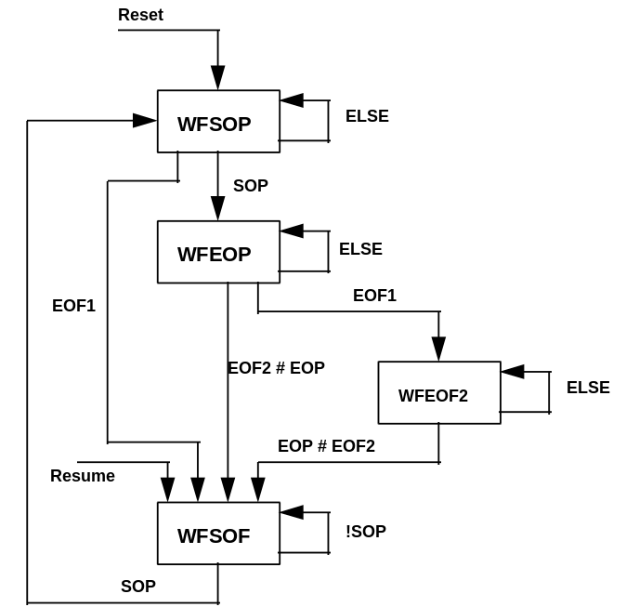
Figure 11-6. Hub Repeater States
The hub repeater maintains state across each packet that is detected and repeated by the hub. The repeater state machine does not need to track more than a single packet and need not, for example, track across multiple packets in a transaction. Figure 11-7 shows how hub states change in the course of a normal packet transmission.
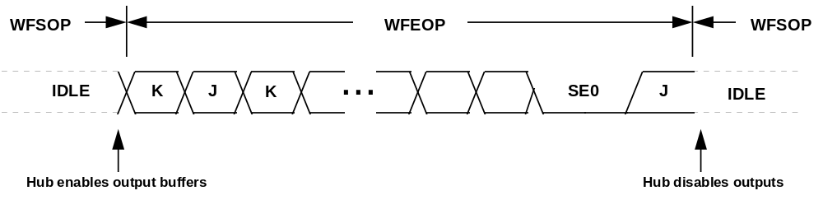
Figure 11-7. Hub States Across a Packet

Hub Repeater States
For upstream connections, a hub repeater transitions between four states: wait for start of packet (WFSOP), wait for end of packet (WFEOP), wait for EOF2 point (WFEOF2), and wait for start of frame (WFSOF). The EOF1 and EOF2 points are described in Section 11.4.5.1. The four states are described below. For downstream connections, the hub transitions between WFSOP, WFEOP, and WFSOF.

Wait for Start of Packet
The Wait for Start of Packet (WFSOP) is the state a hub occupies when there is no packet currently being propagated to or through the hub. Hubs transition to their WFSOP state upon coming out of reset. In the WFSOP state, all of a hub’s ports are in the high impedance state, and all of its enabled ports are in the receive mode with their output buffers in the Hi-Z state. If the root port or any enabled downstream port detects an SOP, the hub establishes connectivity and transitions to the Wait for End of Packet state.

Wait for End of Packet
During the Wait for End of Packet (WFEOP) state, the hub has established its connectivity and is receiving packet traffic on one of its ports. The hub transparently propagates the traffic in either the upstream or downstream direction. Connectivity is maintained until the hub transitions out of this state. A hub transitions out of the WFEOP state when it detects an EOP or if it encounters an end of frame (EOF1) point (refer to Section 11.4.4). Detection of EOP causes the hub to transition back to WFSOP and is the normal sequence. If EOF1 is detected, the hub transitions to the WFEOF2 state.

Wait for EOF2 Point
The WFEOF2 state is entered only when the hub detects its EOF1 point and is still waiting for an EOP from a downstream port. This condition is potentially indicative of babble or loss of bus activity. A hub repeater remains in the WFEOF2 state until an EOP is detected or until its EOF2 point occurs.

Wait for Start of Frame
A hub repeater enters the Wait for Start of Frame (WFSOF) state either when EOF1 is detected and the hub is in the WFSOP state (normal end of frame behavior) or when the hub is in the WFEOF2 state and an EOP or EOF2 point is detected (babble/LOA) behavior.

Hub I/O Buffer Requirements
All hub ports must be able to detect and generate the J, K, and SE0 bus signaling states. This requires that hub ports be able to independently drive and monitor their D+ and D- outputs. Each hub port must have single ended receivers on the D+ and D- lines as well as a differential receiver. Details on voltage levels and drive requirements appear in Chapter 7. Figure 11-8 shows I/O circuitry for a typical hub port.
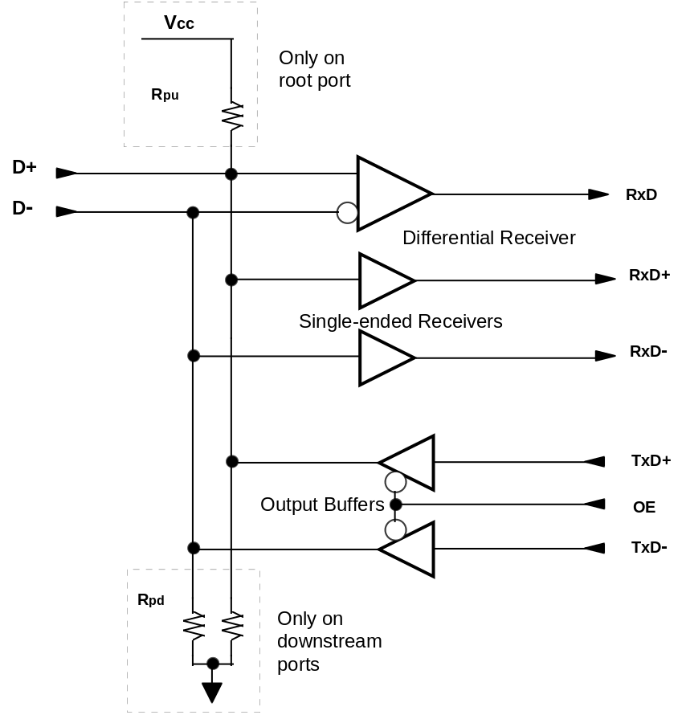
Figure 11-8. Hub Port I/O Driver and Receiver
Table 11-2 defines the hub I/O section’s input and output signals.
Table 11-2. Hub I/O Section Signals
Signal Name | Direction | Description
D+, D- | I/O | External USB data lines
RxD | O | Received differential data
RxD+ | O | Received single-ended value on D+ line
RxD- | O | Received single-ended value on D- line
TxD+ | I | Transmitted data value
TxD- | I | Transmitted data value
OE | I | Output enable/disable on output buffers

D+ and D- are the I/O lines that connect to the USB physical medium. When placed in the Hi-Z state, they are pulled to near the ground or Vcc rails by resistors on the hub and device. RxD is the differential received data. RxD+ and RxD- are the received single ended data. TxD+ and TxD- are used to send differential data and single ended reset and EOP signaling. OE disables the output drivers.

Pull-up and Pull-down Resistors
Hubs, and the devices to which they connect, use a combination of pull-up and pull-down resistors to control D+ and D- in the absence of their being actively driven. These resistors establish voltage levels used to signal connect and disconnect and also maintain the data lines at their idle values when not being actively driven. Each hub downstream port requires a pull down (Rpd) on each data line; the hub root port requires a pull-up (Rpu) on its D+ line. Values for Rpu and Rpd appear in Chapter 7.

Edge Rate Control
Downstream hub ports must support both low speed and full speed edge rates. Full speed signaling specifies a rise/fall time of 4-20 ns. Low speed rise/fall times must be within a 75-300 ns range. Edge rate on a downstream port must be selectable, based upon whether a downstream device was detected as being full speed or low speed. The hub root port always uses full speed signaling, and its output buffers always operate with full speed edge rates.

Hub Fault Recovery Mechanisms
Hubs are the key USB component for establishing connectivity between the host and other devices. It is vital that any connectivity faults, especially those that might result in a deadlock, be detected and prevented from occurring. Hubs need to handle connectivity faults only when they are in the repeater mode. Hubs must also be able to detect and recover from lost or corrupted packets which are addressed to the hub controller. Since the hub controller is, in fact, another USB device, it must adhere to the same time-out rules as other USB devices, as described in Chapter 8.

Hub Controller Fault Recovery
The hub controller must be able to respond to and recover from corrupted and missing packet transmissions. These include lost or corrupted token, data, and handshake packets. The following table describes the possible field level errors which the hub controller can detect and its responses.
Table 11-3. Packet Error Types
Field | Error | Action
PID | PID check, bit stuff | Ignore packet
Address | Bit stuff, address CRC | Ignore token
Data | Bit stuff, data CRC | Discard data

False EOP
Hub handling of false EOP differs depending on whether the hub is operating as a repeater or is being accessed as a device. A hub operating as a repeater transparently propagates signaling, and cannot differentiate between a “good” EOP and a “false” EOP. If any EOP occurs, the hub tears down connectivity and waits for the next SOP. If the packet transmitter continues sending, the hub re-establishes connectivity on the next J to K transition. From a hub’s point of view, a false EOP makes a single packet look like two separate packets. The hub does not participate in false EOP error detection or recovery process when operating in the repeater mode.
When a hub is accessed as an USB device, the hub controller detects and recovers from false EOP the same as any other USB device, as described in Section 8.7.3.

Repeater Fault Recovery
Hubs must be able to detect and recover from conditions that leave them waiting indefinitely for an end of packet or that leaves the bus in a state other than the idle state at the end of a frame, i.e., an SOP without an EOP. There are two such hub fault conditions: loss of activity and babble. Loss of activity (LOA) is characterized by detection of a start of packet (SOP) followed by lack of bus activity (bus is stuck at the idle or K state) and no end of packet (EOP) by frame’s end. Babble is characterized by SOP followed by the presence of bus activity continuing past the end of a frame. Hubs have no notion of allocated bandwidth and must rely upon the frame timer to detect LOA and babble conditions. The recovery mechanism requires that hubs track the host’s frame timing and recover before the beginning of the next frame.
Hub fault recovery operates only in the upstream direction. The host is responsible for detecting and recovering from its own downstream directed errors. Hub repeater fault recovery must meet the following requirements:
- Devices driving illegal states at the end of a frame must be isolated from the bus by disabling the downstream hub port to which the device is connected.
- Hubs must return the bus to the idle state before the start of the next frame if the connectivity was previously established in an upstream direction.
Under non-fault conditions, these requirements are met by virtue of a hub receiving an EOP with every packet and having no bus traffic occur past the end of a frame. Before describing how hubs implement fault recovery, the hub frame will be described.

Hub Frame Timer
Each hub has a frame timer whose timing is derived from the host-generated SOF token and tracks the host SOF packet in both phase and period. The frame timer is reset each time an SOF is detected and is responsible for generating End of Frame (EOF) points. The hub frame timer must track the host SOF and be capable of remaining synchronized to the host SOF for the loss of up to two consecutive SOF tokens. All hubs must have an EOF timer, and it is used to identify two distinct points in time: a point (EOF1) at which time the hub must terminate its own upstream connectivity, and a point (EOF2) by which time the bus must see upstream traffic terminated. The delay between EOF1 and EOF2 corresponds to the timing skews between the host and the hub plus time required for EOP to occur and is illustrated in Figure 11-9.
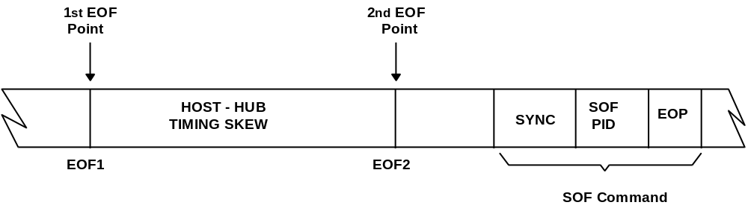
Figure 11-9. Host-Hub EOF Skew
The frame timer must to synchronize to the host’s frame timing for worst case tolerances and offsets between the host and hub. The offsets have to accommodate the hub oscillator tolerance and purposely introduced deviations from 1.000 ms frame timing which occur when the host locks to an external source. The above parameters require a minimum frame length (FLmin) of 11,985 and a maximum frame length (FLmax) of 12,015.

Frame Timer Synchronization
The frame timer is clocked from the hub’s clock source and is synchronized via SOF packets to the host’s frame time. When a hub is first connected to the host the hub’s frame timer is unsynchronized with respect to the host. When the first SOF token is detected the frame timer resets and starts counting once per 12 MHz clock cycle; it continues to count up until the next SOF token is detected. At this time the frame timer is reset and the previous count value is stored as the previous frame length (PFL) count. This value is updated for each frame in which an SOF is detected and represents, in hub clock counts, the host’s frame time. The frame timer is considered locked to the host when the difference between the PFL count and the current count at the end of frame is less than 2 and the PFL lies between FLmin and FLmax.
Should an SOF token fail to be received, the hub uses the previous frame length count as a best approximation to the current frame length. The frame timer is guaranteed to remain synchronized to the host for the loss of up to two consecutive SOF tokens. Hubs must be able to synchronize to the host within 3 frames after detecting the first SOF packet (assuming no missing SOF packets). When a hub comes out of resume its frame timer is not synchronized with that of the host. During this time, when the hub is in the active state, it must be prevented from establishing upstream connectivity until the hub frame timer is synchronized to the host.
The hub’s error recovery, as described in Section 11.4.5, is operational whenever the hub frame timer is locked. If the frame timer is not locked the timer uses FLmin as the default frame length.

Hub Behavior Near EOF
Hub behavior near the end of frame is diagrammed in Figure 11-10. There are two end of frame timing markers, EOF1 and EOF2, corresponding to the first and second EOF points. All hubs receiving upstream traffic, upon detection of EOF1, transmit an EOP upstream for two full speed bit times, drive the bus to the idle state for one bit time, and then float the bus. Starting with EOF1, hubs are not permitted to re-establish upstream connectivity until the end of the next downstream packet which is usually the next SOF token.
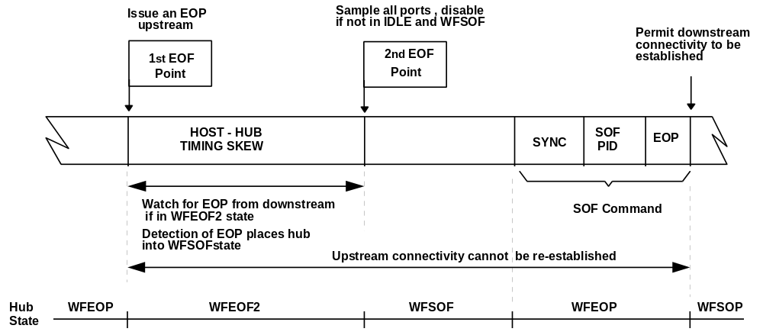
Figure 11-10. Hub Behavior Near End of Frame
Hub behavior at the end of frame is summarized below:
- Hub recovery behavior is applicable only for upstream traffic. If a hub encounters the end of frame and downstream connectivity is established, it maintains connectivity and waits for the next downstream EOP, at which time it tears down connectivity and returns to the WFSOP state.
- At the EOF1 point, all hubs will transmit an upstream EOP, followed by an idle state, and then float the bus, unless connectivity is already established in the downstream direction. The EOP must not truncate or lengthen any upstream directed EOP already in progress.
- Hubs will not allow further connectivity to be established in the upstream direction after EOF1.
- Hubs that were in the WFEOP state at EOF1 must watch for EOPs on the downstream port on which connectivity was established. They must monitor the bus from EOF1 to EOF2.
- If an EOP from downstream is detected by a hub in the WFEOF2 state in the EOF1 to EOF2 window, the hub will transition to the WFSOF state and should see an idle on its port.
- At EOF2, all ports will be sampled for their state, and a port will be disabled if it is not in the proper state (refer to Table 11-4). At EOF2, hubs still in WFEOF2 transition to the WFSOF state. Connectivity is still not allowed from downstream until after a packet is received from the host.
Table 11-4. Hub Behavior at EOF2
 | Not Idle State | Idle State
WFSOF | Disable port | Do not disable port
WFEOF2 | Disable port | Disable port

Skew Requirements
The host and hubs, while all synchronized to the host’s SOF, are subject to certain skews which dictate the length of time between the EOF points, host behavior near EOF, and the next SOF. Figure 11-11 illustrates critical end of frame timing points.
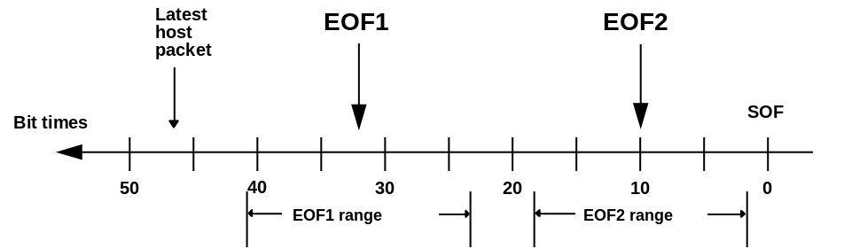
Figure 11-11. EOF Timing Points

Host-Hub Skew
The timing skew between the host’s SOF point and the hub’s SOF timer is minimized by the requirement that the hub track the host. Sources of skew include the fact that hubs may miss SOFs, and that the host frame counter can be adjusted to track an external master clock. The 12 MHz clock is the only clock actually specified, so this is the best granularity available by specification. Assuming a fixed host SOF timing and that two consecutive SOFs can be missed, the maximum cumulative host-hub skew without host timing wander is ±3 clocks. Assuming that the host clock may be adjusted by up to one bit time per frame, then the host can walk away from the hub by 1 + 2 + 3 = 6 clocks. The maximum host-hub skew is the sum of these two components or ±9 clocks.
The second EOF point must be sufficiently separated from the SOF point to permit hubs to recover and be ready to receive the SOF token from the host. A hub must finish sending its EOP before a hub to which it is attached reaches its second EOF point. This means that all hub EOF2 points must occur at least one bit time before the host issues SOF. All hub EOF2 points must lie within a ±9 bit time window; therefore, EOP must lie outside this window and complete at least 2 x 9 + 1 = 19 bit times before host SOF.
The next step is calculating how long it takes to generate EOP and how far back from SOF it must occur. Transmitting EOP requires four bit times. Therefore, a hub must start sending its EOP no later than 19 + 4 = 23 bit times before SOP. For a hub to be sure that it starts no later than the 23rd bit time, it must start 9 bit times before that or at bit time 32, which is the value of the first EOF point. The earliest that a hub might start sending EOP is 9 bit times before the first EOF point or at bit time 41.
A hub must not see a packet from the host start after the hub reaches its first EOF point. This could be as early as 41 bit times before SOF. Hub propagation delay must also be figured into the delay budget. The per-hub delay is approximately one bit time; so for a worst case topology of six hubs away from the host, there will be an additional 6 bit times of delay. Therefore, the host’s EOF point for transmit is 41 + 6 = 47 bit times from SOF, relative to the host’s SOF timer. If the host is still transmitting at bit 47 and not able to complete before SOF, it must force an error via a bit stuffing violation (at least eight 1’s), followed by an EOP. If the host is still receiving a packet or an EOP at bit 41, it should treat the packet as being in error. Table 11-5 summarizes hub and host EOF timing points.
Table 11-5. Hub and Host EOF Timing Points
Description | Number of Bits From Start of SOF | Notes
EOF1 | 32 | End of frame point #1
EOF2 | 10 | End of frame point #2
Host invalidates full speed Tx packet | 47 | Latest that host may start a full speed packet
Host invalidates low speed Tx packet | 184 | Latest that host may start a low speed packet (rounded up to the nearest low speed bit time)
Host invalidates Rx packet | 41 | Host treats any packet still being received at bit time 41 as bad

Suspend and Resume
Hubs must support suspend and resume both as a USB device and also in terms of propagating the suspend and resume signaling. Hubs support both global and selective suspend and resume. Selective suspend and resume are implemented via per port enable/disable. Global suspend is implemented by the host through the hub’s root port. Global resume may be initiated either from the host or from a hub’s downstream port.

Global Suspend and Resume
Global suspend is initiated by the host shutting off downstream traffic to the entire bus. A hub enters the suspend state if it detects a continuous idle state on its root port for at least 3.0 ms. When placed into the suspend state, a hub puts its repeater into the WFSOP state, floats all of its output drivers, maintains static values of all its control and status bits, and preserves the current state information for each of its downstream ports. A suspended hub has its clocks turned off, so it has no concept of time and can only respond to bus transitions.
Hub resume may be initiated by any bus transition on a hub’s root port or on a downstream port in the enabled state. Hub resume may also be initiated by the connect/disconnect of a device on a downstream port in the disconnected, disabled, or suspended states. If a transition occurs on an enabled downstream port then the hub immediately reflects an idle to a resume bus transition to that port, all other enabled downstream ports, and its root port. Figure 11-12 shows the timing relationships during a resume sequence in which a device initiates a wake up to a hub.
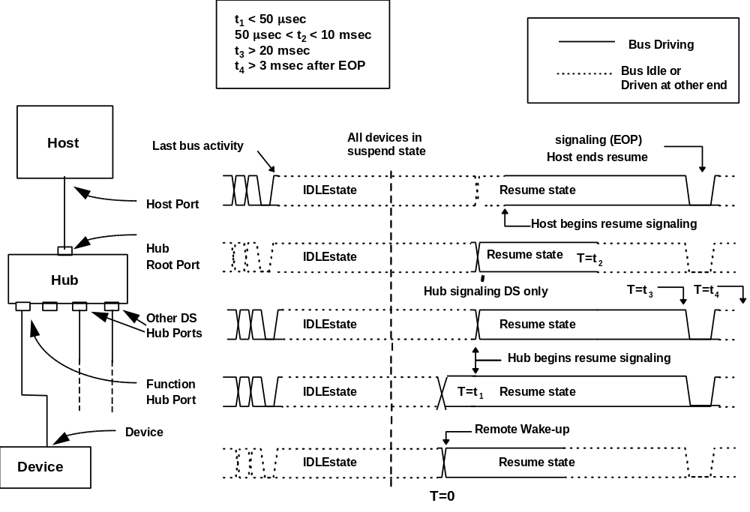
Figure 11-12. Resume Signaling
There are four time parameters that hubs must conform to, as shown in Figure 11-12. T=0 represents the time when the resume signaling arrives at the port. t₁ is the time by which a hub must respond by driving resume onto the upstream port and all enabled downstream ports. t₂ is the time at which the hub must stop driving an upstream initiated resume to its root port and reflect the bus state now being driven to its root port onto its downstream ports. The interval, t₃ is the time that a hub must generate downstream K signaling to the device that initiated the resume. t₄ is the time that the hub must wait after detecting the downstream low speed EOP until it can set its interrupt bit, indicating that a resume has occurred after a selective suspend.
When a device drives an idle to resume transition upstream to the hub the hub responds by driving the resume (K) state onto the bus to the root port and to all enabled downstream ports including the port which initiated the resume. (It is acceptable to drive both ends of a bus segment to the same state.) After driving the resume state, the hub begins the process of returning to a fully awake state (e.g., restart clocks). When the hub is awake, it will reverse the connectivity so that the K state on the hub’s root port is sustaining the K on its downstream ports. (This scenario assumes that the hub immediately above the one in question has received resume signaling and is now driving it downstream.) A hub may not reverse the connectivity any faster than 50 μs, nor slower than 10 ms after receiving a resume from a downstream. The t₂ parameter also implies that a hub must be fully awake no later than 10 ms after receiving a resume request.
The resume signal propagates upstream until it reaches the host. The host reflects the resume signaling downstream for at least 20 ms, which guarantees that all devices will have time to wake up and detect the downstream resume signaling. The host terminates the resume sequence by driving an EOP for two low speed bit times. The EOP is interpreted as a valid end of packet, causes all hubs to tear down their connectivity and informs all devices on the bus that the resume sequence has completed. The device that initiated the resume must wait until it detects EOP to determine that the resume sequence has completed.
Hubs must be able to propagate downstream traffic immediately after the end of resume to prevent downstream devices from re-entering the suspend state. The hub controller must be able to receive packet traffic no later than 10 ms after the end of resume. Note: a remote wakeup device may not start a resume sequence until 5 ms after the last bus activity. This allows the hub to go into the suspend state so that it will resume all ports and not just the full speed ones. Table 11-6 summarizes the behavior of hubs in response to host initiated, downstream signaling.
Table 11-6. Suspended Hub Behavior During Global Resume
Port Status and Signaling Type | Downstream Port Response
Port enabled, resume (K) received | Signal resume downstream
Port disabled, resume (K) received | Do nothing
Port suspended, resume (K) received | Signal resume downstream

Resume and Hub Frame Timer
When a hub transitions from the suspended to the awake state, its frame timer is not operational and the hub’s EOF timing recovery circuitry will not work until the first SOF has been received. To prevent a babbling downstream device on a recently resumed bus segment from locking up the bus it is necessary to prevent hubs from propagating upstream traffic while the hub is in the awake state until the hub’s frame timer has started. This is achieved by making the hub repeater state machine transition to its WFSOF state upon coming out of resume. While the hub repeater is in the WFSOF state all upstream traffic is ignored. The repeater state machine remains in the WFSOF state until an SOF is detected, at which time it transitions to the WFEOP state. Downstream traffic is unaffected by the status of the frame timer. To prevent needless time-outs it is recommended that the host not send any packets addressed to devices on a just resumed bus segment until the host has issued at least one SOF token to the recently resumed hub or hubs. This condition is guaranteed by virtue of the fact that a hub does not report a resume detect to the host until 3.0 ms after the resume sequence completes.

Selective Suspend and Resume
Selective suspend and resume provide a means for placing a single device or a bus segment into a low power state. Selective suspend relies on the ability of a hub to selectively suspend individual ports via a SetPortFeature(PORT_SUSPEND) request, which places a port on a hub (referred to as the disabling hub) into the suspend state (see Figure 11-4 and Figure 11-5 for state diagrams). In the suspend state a port is prevented from propagating any bus activity (except the port reset request) downstream, and the port can only reflect upstream bus state changes via the hub’s status bits; i.e., an awake hub cannot propagate upstream traffic from a suspended port to its root port. The hub must also insure that the port accessed via the port suspend request is not suspended in the middle of a packet transaction. In response to a port suspend, all devices downstream of the targeted port go into suspend after failing to see bus activity for 3.0 ms while the bus is in the idle state The port suspend request is only understood by an awake hub. If the host wishes to send the request to a suspended hub, it must first wake the hub and then issue the desired request.

Selective Resume to an Awake Hub
Figure 11-13 shows the signaling between a device and an awake hub (Hub Y). If a hub port is selectively suspended and the hub is in the awake state, then the hub must prevent any bus activity on the suspended port from being reflected to other enabled ports on the hub, as these ports may be transporting bus traffic. In addition, the resume on Port B must not propagate to other suspended ports (such as Port C). The solid line represents the extent of the resume signaling, which stops at Port B of Hub Y. Resume signaling may occur either from a host request to directly re-enable the hub port (downstream resume) or from a device on the suspended bus segment (upstream resume).
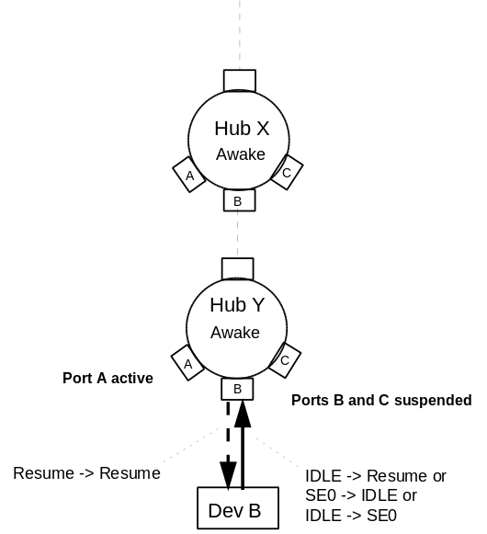
Figure 11-13. Selective Resume Signaling on an Awake Hub
Upstream resume may be initiated by an idle to resume (device issues resume), an idle to SE0 (device disconnect) or an SE0 to idle (device attach) bus transition on a suspended port. Hub Y, Port B must reflect a resume state within 50 μs of receipt of resume to inform the remote wakeup device (Device B) that its resume has been detected. If the transition on Port B was not idle to resume (J to K), Port B does not reflect any signaling downstream but continues to maintain its output buffers in the Hi-Z state. This latter case covers connect and disconnect events.
The receipt of resume signaling by Port B of Hub Y causes the following sequence of events to occur.
- Hub Y, Port B reflects the resume signaling downstream within 50 μs of resume detection.
- Hub Y maintains resume signaling downstream for at least 20 ms.
- At the end of 20 ms, the hub terminates the resume with a low speed EOP (Downstream traffic starts flowing through the port at this time.)
- 3.0 ms after the end of EOP, an interrupt in the hub controller is set.
The hub is responsible for maintaining all the resume timing parameters. The host need not keep track of any time and can poll the hub via a GetPortStatus request to determine that a resume event has occurred. Since the hub process selective resumes autonomously, the host will not receive direct signaling in the event of a selective resume that does not originate from the host. It is necessary for the host to poll downstream hubs (as part of its status polling) to determine that a selective resume event has completed. The 3.0 ms delay between the end of resume signaling and the setting of the interrupt bit guarantees that no packet traffic with a newly resumed device will occur until newly resumed devices have had time to synchronize their frame timers with SOF; however, downstream devices will see traffic and SOF tokens not specifically addressed to them. When a resume is initiated by a downstream device, the host polls for the end of selective resume as part of its status polling The hub must also insure that the port is not re-enabled in the middle of a packet transaction.
Downstream selective resume may also be initiated via a ClearPortFeature(PORT_SUSPEND) request; This request causes the disabled port to drive resume signaling onto the bus for at least 20 ms, followed by a low speed EOP. As with a device initiated resume, the interrupt bit in the hub controller, signaling the end of resume, must not be asserted until 3.0 ms after the end of the low speed EOP. The host must poll the hub interrupt to determine when the resume has completed. Table 11-7 summarizes the behavior of an awake hub in the presence of resume signaling originating from downstream.
Table 11-7. Awake Hub Behavior During Resume
Port Status and Signaling Type | Signaled Port Response | Adjacent Enabled Port Response | Adjacent Disabled Port Response | Adjacent Suspended Port Response
Port suspended, resume (K) received | Reflect K downstream on signaled port. Initiate port wake-up. Set status bits and interrupt. | Do nothing | Do nothing | Do nothing
Port enabled, disabled or suspended and disconnect received | Set port disconnect, disable and change status bits. Set interrupt. | Do nothing | Do nothing | Do nothing
Port disabled and connect received | Set port connect, and change status bits. Set interrupt. | Do nothing | Do nothing | Do nothing

Selective Resume to a Suspended Hub
It is possible for the host to suspend a hub port and then suspend the entire hub. In this case, the hub’s connectivity changes once the hub enters the suspended state. Figure 11-14 illustrates device initiated connectivity for suspended ports on a suspended hub. Device B may issue connect, disconnect, or resume signaling to Hub Y, Port B. In response, Hub Y must convert that signaling into a (J to K) transition, regardless of what signaling device B sends upstream. The hub drives the resume state to the root port and to other enabled downstream ports (Port A). Hub Y must drive Port B to the resume state if Device B drove the bus to the resume state. If Port B detects a connect or disconnect event, the hub does not drive a resume downstream to the signaling port, but maintains the port’s output buffers in the Hi-Z state.
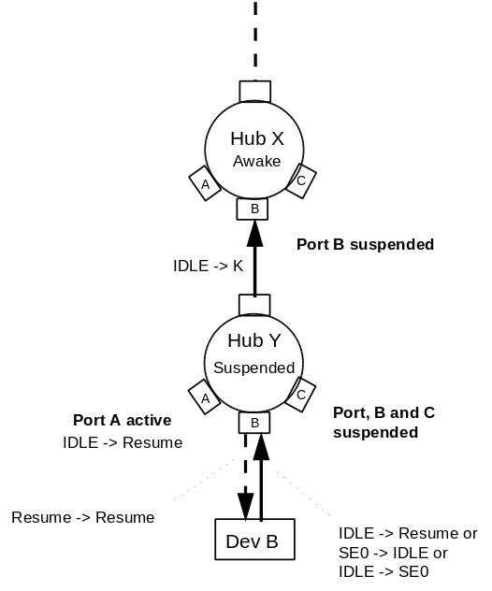
Figure 11-14. Device-Initiated Resume for Suspended Hub

Table 11-8. Suspended Hub Behavior During Resume
Port Status and Signaling Type | Signaled Port Response | Adjacent Enabled Port Response | Adjacent Disabled Port Response | Adjacent Suspended Port Response
Port enabled, resume (K) received | Reflect resume upstream and downstream. Do not set status bits | Signal resume downstream | Do nothing | Do nothing
Port disabled, resume (K) received | Do nothing | Do nothing | Do nothing | Do nothing
Port suspended, resume (K) received | Reflect K upstream on root port and downstream on signaled port | Signal resume downstream | Do nothing | Do nothing
Port enabled, disabled or suspended and disconnect received | Reflect resume upstream. Start hub wake-up. Update port connect and change status bits, set interrupt | Signal resume downstream | Do nothing | Do nothing
Port disabled and connect received | Reflect resume upstream. Start hub wake-up. Set port connect, and change status bits, set interrupt | Signal resume downstream | Do nothing | Do nothing
Host initiated signaling for suspended hubs is shown in Figure 11-15. Waking up a device at the bottom of a string of suspended hubs is a multi step procedure which is described below.
- The host takes Port B in Hub X out of suspend by issuing a port resume request to the hub. In response to the resume request, Hub X initiates the resume signaling by driving at least 20 ms of K signaling followed by a low speed EOP out its Port B. Hub Y sees the resume signaling and starts its wake up process. The EOP indicates that the resume sequence is completed. 3.0 ms after the EOP is issued by Hub X, the resume complete status bit in Hub X’s controller is set indicating that the resume sequence is completed. At the end of this stage Hub X, port B is in the enabled state and Hub Y is awake.
- The next step is taking Port B on Hub Y out of the suspended state to the enabled state. The procedure is identical to that described in the previous step except that the request is issued to Hub Y, Port B instead of Hub X. At the end of this step, Port B on Hub Y is enabled and device B has received resume signaling and is awake. At this time the host may communicate with Device B. This resume policy permits the bus to be sequentially suspended while permitting any device on the suspended segment to awaken the bus. It also permits nested hubs to be awakened one tier at a time.
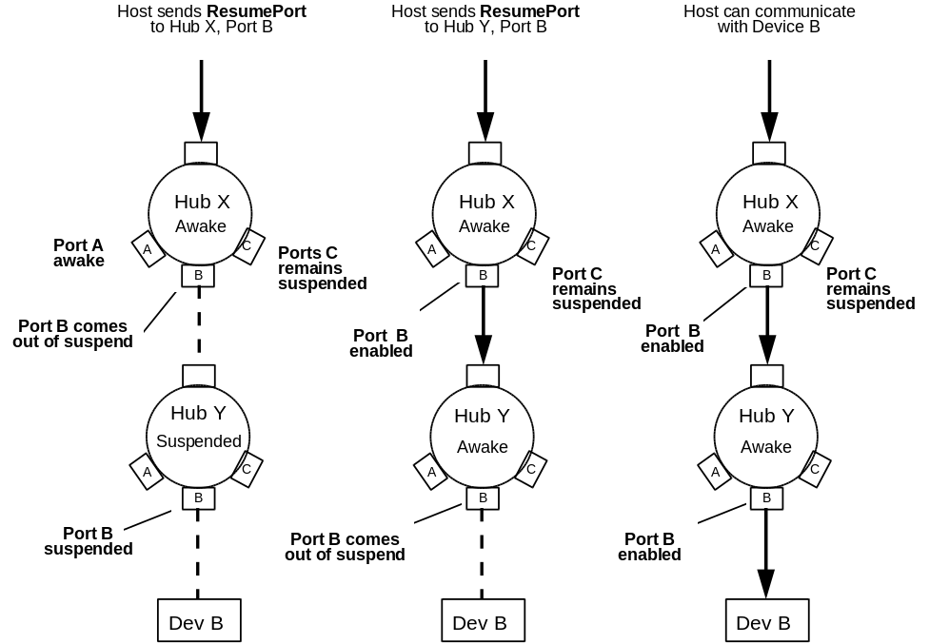
Figure 11-15. Host-initiated Resume Through Suspended Hubs

USB Hub Reset Behavior
A USB hub must be able to generate a per port reset via a host request and accept reset signaling on their root port. The following sections describe hub reset behavior and its interactions with resume, attach detect, and power-on.

Hub Receiving Reset on Root Port
Reset signaling to a hub is defined only in the downstream direction which is at the hubs’ root port. An awake hub may start its reset sequence if it detects 2.5 μs or more of continuous SE0 signaling and must complete its reset sequence no later than 5.5 μs of continuous SE0. The 2.5 μs lower limit is set by a need to prevent low speed EOP strobes (which are up to 1.3 μs in length) from being interpreted as reset. A suspended hub must interpret the start of reset edge as a resume signaling event and begin its wake-up sequence. The hub must be awake and have completed reset no later than 10 ms the completion of reset signaling
After completion of reset a hub controller is in the following state:
- Hub controller default address is 0
- Hub control bits set to default values
- Hub repeater is in the WFSOP state
- All downstream ports in Powered Off state (power-switched hubs)
- All downstream ports in Disconnected state (non power-switched hubs)
If a bus contains hubs with power-switched ports, the host reset is not guaranteed to propagate all the way downstream. The host has to guarantee that each tier is reset when it goes through the enumeration process, and the enumeration reset is done on a tier by tier basis. (However, the powered off devices are effectively reset, if they are off long enough, and self-powered devices/hubs below them reset themselves and their downstream ports.)

Per Port Reset
A hub can exercise per-port resets via the SetPortFeature(PORT_reset) request. This request specifies a downstream port number. In response to a SetPortFeature(PORT_reset) request, the hub drives an SE0 onto its downstream port for at least 10 ms, returns the bus to the idle (J) state, and the places the port into the enabled state. SetPortFeature(reset) is an atomic operation; the 10 ms delay between start and end of reset is controlled by the hub. The hub must be able to return to the host the status of the reset request; i.e., whether the reset has completed, so that the host does not have to keep track of elapsed time during the reset operation. The port reset request can be issued to a port in any state; however, no downstream signaling is generated if the reset is issued to a port in the powered off or disconnected states.
Device attach detection requires that the port in question be power-switched on (if power switching is an option). When a device is attached, a hub can detect an attach via an SE0 to DIFF1 or DIFF0 bus transition. This requires that disabled ports not be driven by the hub while attach detection is being performed. This should not be a problem, as the port will have been disabled and its output drivers floated by detection of the previous detach event. The host can determine the device’s speed by examining whether D+ or D- is pulled high.
Before a port to which a device has been connected can be enabled we must be assured that the device has been reset. Since it is not possible to rely on loss of Vbus, caused by a disconnect event, to reset the device, a port must be reset before being enabled. This is performed via an atomic SetPortFeature(PORT_reset) request which issues SE0 reset signaling and then enables the port. USB devices, including hubs, must be able to respond to a host access no later than 10 ms after reset is de-asserted.

Power Bringup and Reset Delays
Since USB components may be hot plugged, and hubs may implement power switching, it is necessary to comprehend the delays between power switching and/or device attach and when the device’s internal power has stabilized.
Figure 11-16 shows the case where a device is connected to a hub whose port is power switched on. There are two delays that need to be taken into consideration. Δt1 is the amount of time required for the hub port switch to operate. Δt2 is the time required for the device’s internal power rail to stabilize. If a device were plugged into an non-switched or already switched on port, only Δt2 would need to be considered. Δt1 is a function of the type of hub port switch, and this parameter may be read via a hub controller command. Δt2 must be less than 100 ms for all hub and device implementations. It is necessary to specify a worst-case upper limit on Δt2, since it is device specific and cannot be reported until after the power-on and reset sequences are completed.
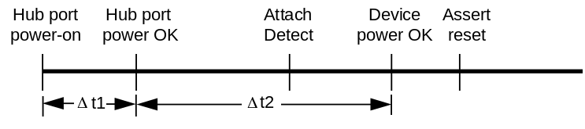
Figure 11-16. Power-on timing
As Figure 11-16 shows, it is possible to detect a device attach before its internal power has stabilized. One must guarantee a minimum of 10 ms during which a device’s internal power is stable and reset is asserted. Therefore, reset cannot be asserted immediately after device attach but must instead wait for Δt2 to elapse. If the hub implements power switching, Δt1 + Δt2 must elapse before reset is applied.
USB devices must power on in such a manner that they do not drive D+ or D- (except with the pull-up resistor) during the reset process. This is required so the upstream hub can drive reset downstream and be assured that the downstream device will see the reset signaling.

Hub Power Distribution Requirements
Hubs can supply a specified amount of power to downstream components and are responsible for reporting their power distribution capabilities to the host during enumeration. USB requirements stipulate that generalized legal bus topologies be supported while at the same time preventing power-up of illegal topologies. An illegal power topology is one that violates the power contract established during enumeration.
Hubs may be either locally powered or bus powered, or a combination of the two. For example, a hub may derive power for its SIE and root port pull-up resistors from the bus while obtaining power for its downstream ports from a local power supply. A hub can only supply power in a downstream direction, and must never drive power upstream. A complete discussion of hub power distribution appears in Section 7.2.
Bus powered hubs must have port power switching for its downstream ports and are required to power off all downstream ports when the hub comes out of power-up, or when it receives a reset on its root port. Ports may also be switched on and off under host software control. An implementation may provide power switching on a per port basis or have a single switch for all the ports. Port reset requests do not affect the status of the power switching for a port. A hub port must be powered on in order to perform connect detection from the downstream direction.

Overcurrent Indication
For reasons of safety, all locally powered hubs must implement current limiting on their downstream ports. Under no conditions may more than 25 VA be drawn from any USB hub port. (The actual overcurrent trip point may be lower than this figure). If an overcurrent condition occurs, even if it is only momentary, it must be reported to the hub controller. This is done via an overcurrent state that is reflected through hub requests. The overcurrent detect state is entered on overcurrent detect and cleared by a host request or upon reset. Detection of overcurrent must disable all affected ports. If the overcurrent condition has caused a permanent disconnect of power (such as a blown fuse), the hub must report it upon coming out of reset or power-up.
Overcurrent protection may be implemented over all downstream ports in aggregate, or on a per port basis. The ports may optionally be split into two or more subgroups, each with its own overcurrent protection circuit.

Hub Endpoint Organization
The Hub Class defines one additional endpoint beyond Endpoint 0, which is required for all devices: the Status Change endpoint. The host system receives port and hub status change notifications through the Status Change endpoint. The Status Change endpoint supports interrupt transfers. If the hub has not detected changes on any of its ports, nor any hub status changes, the hub returns a NAK to requests on the Status Change endpoint. When the hub detects any status change, the hub responds with data describing the entity that changed. Host software driving the hub is responsible for examining the data transferred to determine which entity changed. Hubs are logically organized as shown in Figure 11-17.
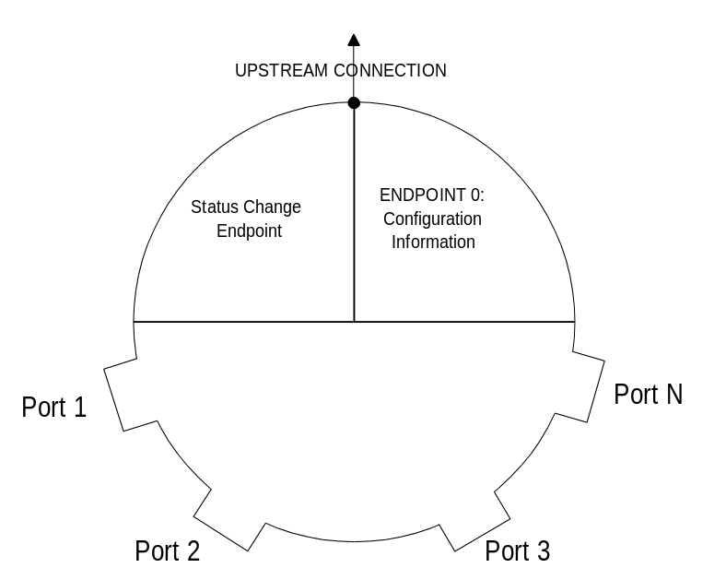
Figure 11-17. Example Hub Organization

Hub Information Architecture and Operation
Hub Descriptors and Hub/Port Status and Control are accessible through the default pipe. When a hub detects a change on a port or when the hub changes its own state, the Status Change endpoint transfers data to the host in the form specified in Section 11.8.3.
USB hubs detect changes in port states. Devices attached to the ports on a hub can cause various hardware events. In addition, host system software can cause changes to a hub’s state by sending commands to the hub. Since there are two sources of changes to the hub, USB hubs report change information for each of the hardware-caused events. The hub continues to report a status change when polled until that particular event has been successfully acknowledged by the host. Using this reporting mechanism, system software determines what changes occurred since the last event reported by the hub. This approach makes it possible to minimize the device state information that system software must carry.
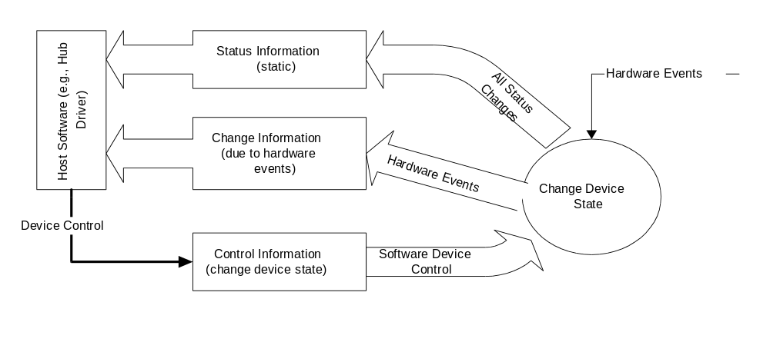
Figure 11-18. Relationship of Status, Status Change, and Control Information to Device States
Host software uses the interrupt pipe associated with the Status Change endpoint to detect changes in hub and port status.

Port Change Information Processing
Hubs report a port's status through port commands on a per-port basis. Host software acknowledges a port change by clearing the change state corresponding to the status change reported by the hub. The acknowledgment clears the change state for that port so future data transfers to the Status Change endpoint do not report the previous event. This allows the process to repeat for further changes (see Figure 11-19.)
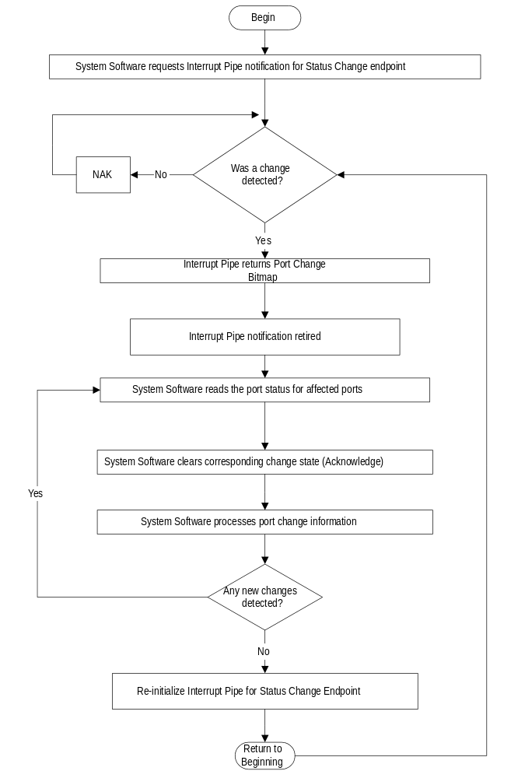
Figure 11-19. Port Status Handling Method

Hub and Port Status Change Bitmap
The Hub and Port Status Change Bitmap, shown in Figure 11-20, indicates whether the hub or a port has experienced a status change. This bitmap also indicates which port(s) have had a change in status. The hub returns this value on the Status Change endpoint. Hubs report this value in byte-increments. That is, if a hub has six ports, it returns a byte quantity and reports a zero in the invalid port number field locations. System software is aware of the number of ports on a hub (this is reported in the hub descriptor) and decodes the Hub and Port Status Change Bitmap accordingly. The hub reports any changes in hub status on bit 0 of the Hub and Port Status Change Bitmap.
The Hub and Port Status Change Bitmap size varies from a minimum size of one byte. Hubs only report as many bits as there are ports on the hub, subject to the byte-granularity requirement (i.e., round up to the nearest byte).
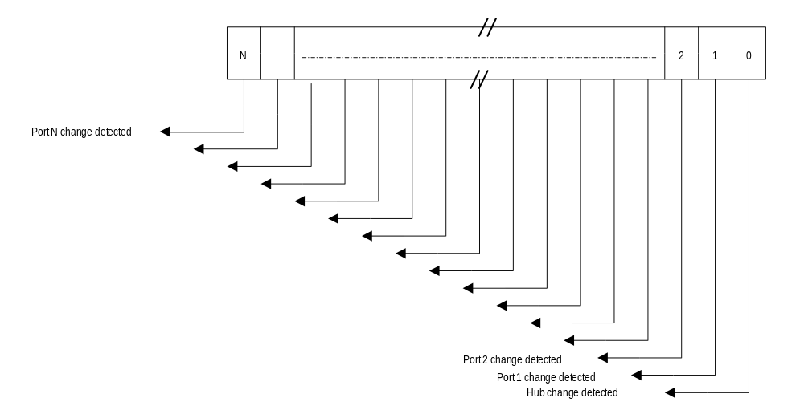
Figure 11-20. Hub and Port Status Change Bitmap
Any time the Status Change endpoint is polled by the host controller and any of the Status Changed bits are non-zero, the Hub and Port Status Change Bitmap is returned. Hubs sample the change at the End of Frame (EOF2) in preparation for a potential data transfer in the subsequent USB frame. If a change was detected, then data will be transferred through the Status Change endpoint in the subsequent USB frame. Figure 11-21 shows the sampling mechanism for hub and port change bits.
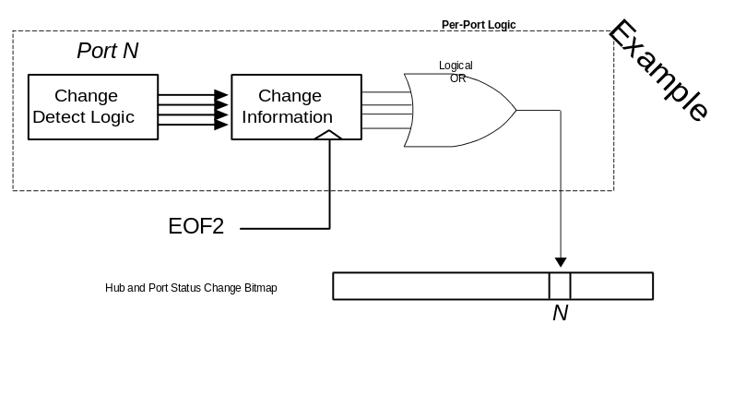
Figure 11-21. Example Hub and Port Change Bit Sampling

Hub Configuration
Hubs are configured through the standard USB device configuration commands. An unconfigured hub behaves like all other unconfigured devices with respect to power requirements and addressability. Unconfigured hubs do not turn power onto the downstream ports. Configuring a hub enables the Status Change endpoint. System software issues commands to the hub to switch port power on and off at appropriate times.
System software examines hub descriptor information before configuration to determine the hub’s characteristics. By examining the hub’s characteristics, system software ensures that illegal power topologies are not allowed by not powering on the hub’s ports if doing so would violate the USB power topology.

Hub Port Power Control
Hubs allow port power to be controlled by the host system. As described previously, hubs support per-port or gang-mode power switching on the downstream ports. Switching port power is done via hub commands, defined below. Hubs with per-port power switching may also allow gang-mode power switching by specifying a certain value in a request field in the port power control request (refer to the SetPortFeature(port_power) request definition in Section 11.12.2.9).
Hubs may wish to mask the gang-mode power control for certain ports. This allows a hub to independently control the power switching for certain ports, regardless of the general port switching characteristics. For example, consider a hub with gang-mode port power switching that has a permanently attached device on a port (an “embedded port”). If the Port Power Control Mask field for the embedded port indicates that gang-mode power switching is masked, any hub commands that control the ports in gang-mode will not affect the embedded port.

Descriptors
Hub descriptors are derived from the general USB device framework. Hub descriptors define a hub device and the ports on that hub. The host accesses hub descriptors through the hub’s default pipe.
The USB Specification (refer to Chapter 9) defines the following descriptors:
- Device
- Configuration
- Interface
- Endpoint
- String (optional)
The hub class defines additional descriptors (refer to Section 11.11.2). In addition, vendor-specific descriptors are allowed in the USB device framework. Hubs support standard USB device commands as defined in Chapter 9.

Standard Descriptors
The hub class pre-defines certain fields in standard USB descriptors. Other fields are either implementation-dependent or not applicable to this class.
Note: For the descriptors and fields shown below, the bits in a field are organized in a little-endian fashion; that is, bit location 0 is the least significant bit and bit location 8 is the most significant bit of a byte value.
Device Descriptor
bDeviceClass = HubClass
bDeviceSubClass = HubSubClass
wMaxPacketSize0 = 8 bytes
Interface Descriptor
bNumEndpoints = 1
bInterface = 1
Configuration Descriptor
MaxPower = The maximum amount of bus power this hub will consume in this configuration.
Endpoint Descriptor (for Status Change Endpoint)
bEndpointAddress = Implementation dependent
wMaxPacketSize = Implementation dependent
bmAttributes = Direction = In, Transfer Type = Interrupt (0b00000111 )
bInterval = 0xFF (Maximum allowable interval)
The hub class driver retrieves a device configuration from host system software using the GetDescriptor device request. The first endpoint descriptor returned by GetDescriptor request is, by specification, the Status Change endpoint descriptor. Hubs may define additional endpoints beyond the minimum required by this class definition. However, hubs conforming to this class standard always return the Status Change endpoint as the first endpoint descriptor in the standard interface.

Class-specific Descriptors

Hub Descriptor

Table 11-9. Hub Descriptor
Offset | Field | Size | Description
0 | bDescLength | 1 | Number of bytes in this descriptor, including this byte.
1 | bDescriptorType | 1 | Descriptor Type
2 | bNbrPorts | 1 | Number of downstream ports that this hub supports.
3 | wHubCharacteristics | 2 | D1..D0: Power Switching Mode  00 - Ganged power switching (all ports’ power at  once)  01 - Individual port power switching  1X - No power switching (ports always powered  on when hub is on and off when hub is off).  D2: Identifies a Compound Device  0 - Hub is not part of a compound device  1 - Hub is part of a compound device  D4..D3: Over-current Protection Mode  00 - Global Over-current Protection. The hub  reports over-current as a summation of all  ports’ current draw, without a breakdown of  individual port over-current status.  01 - Individual Port Over-current Protection. The  hub reports over-current on a per-port basis.  Each port has an over-current indicator.  1X -No Over-Current Protection. This option is  only allowed for bus-powered hubs that do not  implement over-current protection.  D15..D5: Reserved
5 | bPwrOn2PwrGood | 1 | Time (in 2 ms intervals) from the time power on sequence begins on a port until power is good on that port. System software uses this value to determine how long to wait before accessing a powered-on port.
6 | bHubContrCurrent | 1 | Maximum current requirements of the hub controller electronics in mA.
7 | DeviceRemovable | Variable depending on number of ports on hub | Indicates if a port has a removable device attached. If a non-removable device is attached to a port, that port will never receive an insertion change notification. This field is reported on byte-granularity. Within a byte, if no port exists for a given location, the field representing the port characteristics returns “0”.  Bit definition:  0 - Device is removable  1 - Device is not removable (permanently  attached)  This is a bitmap corresponding to the individual ports on the hub:  Bit 0: Reserved for future use  Bit 1: Port 1  Bit 2: Port 2  Etc.  Bit n: Port n (implementation dependent, up to a maximum of 255 ports).
Variable | PortPwrCtrlMask | Variable depending on number of ports on hub | Indicates if a port is not affected by a gang-mode power control request. Ports that have this field set always require a manual SetPortFeature(port_power) request to control the port’s power state.  Bit definition:  0 - Port does not mask the gang-mode power control capability.  1 - Port is not affected by gang-mode power commands. Manual commands must be sent to this port to turn power on and off.  This is a bitmap corresponding to the individual ports on the hub:  Bit 0: Reserved for future use.  Bit 1: Port 1  Bit 2: Port 2  Etc.  Bit n: Port n (implementation dependent, up to a maximum of 255 ports).

Requests

Standard Requests
Table 11-10. Hub Responses to Standard Device Requests
bRequest | Hub Response
clear_feature | Standard
GET_CONFIGURATION | Standard
GET_DESCRIPTOR | Standard
GET_INTERFACE | Optional. Hubs only required to support one interface
GET_STATUS | Standard
SET_ADDRESS | Standard
SET_CONFIGURATION | Standard
SET_DESCRIPTOR | Optional
set_feature | Standard
SET_INTERFACE | Optional. Hubs only required to support one interface
synch_frame | Optional. Hubs are not required to have isochronous endpoints.

Class-specific Requests
The hub class defines requests to which all hubs must respond.
Table 11-11. Hub Class Requests
Request | bmRequestType | bRequest | wValue | wIndex | wLength | Data
ClearHubFeature | 00100000B | CLEAR_ FEATURE | Feature Selector | Zero | Zero | None
ClearPortFeature | 00100011B | CLEAR_ FEATURE | Feature Selector | Port | Zero | None
GetBusState | 10100011B | get_ state | Zero | Port | One | Per Port Bus State
GetHubDescriptor | 10100000B | get_DESCRIPTOR | Descriptor Type and Descriptor Index | Zero or Language ID | Descriptor Length | Descriptor
GetHubStatus | 10100000B | GET_ STATUS | Zero | Zero | Four | Hub Status and Change Indicators
GetPortStatus | 10100011B | GET_ STATUS | Zero | Port | Four | Port Status and Change Indicators
SetHubDescriptor | 00100000B | SET_DESCRIPTOR | Descriptor Type and Descriptor Index | Zero or Language ID | Descriptor Length | Descriptor
SetHubFeature | 00100000B | set_ feature | Feature Selector | Zero | Zero | None
SetPortFeature | 00100011B | set_ feature | Feature Selector | Port | Zero | None

Table 11-12. Hub Class Request Codes
bRequest | Value
get_ status | 0
clear_ feature | 1
get_state | 2
set_ feature | 3
reserved for future use | 4-5
get_descriptor | 6
set_descriptor | 7

The following are the valid feature selectors for the hub class. See GetHubStatus and GetPortStatus for a description of the features.
Table 11-13. Hub Class Feature Selectors
 | Recipient | Value
c_hub_local_power | Hub | 0
c_hub_over_current | Hub | 1
port_connection | Port | 0
port_enable | Port | 1
port_suspend | Port | 2
port_over_current | Port | 3
port_reset | Port | 4
port_power | Port | 8
port_low_speed | Port | 9
c_port_connection | Port | 16
c_port_enable | Port | 17
c_port_suspend | Port | 18
c_port_over_current | Port | 19
c_port_reset | Port | 20

Clear Hub Feature
This request resets a value reported in the hub status.
bmRequestType | bRequest | wValue | wIndex | wLength | Data
00100000B | clear_ feature | Feature Selector | Zero | Zero | None

Clearing a feature disables that feature; refer to Table 11-13 for the feature selector definitions. If the feature selector is associated with a change indicator, clearing that indicator acknowledges the change. Both c_hub_local_power and c_hub_over_current may be acknowledged using this request.

Clear Port Feature
This request resets a value reported in the port status.
bmRequestType | bRequest | wValue | wIndex | wLength | Data
00100011B | clear_ feature | Feature Selector | Port | Zero | None
The port number must be a valid port number for that hub, greater than zero.
Clearing a feature disables that feature; refer to Table 11-13 for the feature selector definitions. If the feature selector is associated with a change indicator, clearing that indicator acknowledges the change. Changes in connection, enable, suspend, reset, and over-current status are acknowledged using this request.
Clearing the port_suspend feature causes a host-initiated resume on the specified port. Clearing the PORT_ENABLE feature causes the port to be disabled. Clearing the PORT_POWER feature causes the port to be powered off, subject to the constraints due to the hub’s method of power switching. If a hub uses gang power switching, all ports must be requested to power off before any of the ports actually power off.

Get Bus State
This is an optional per-port diagnostic request which reads the bus state value, as sampled at the last EOF2.
bmRequestType | bRequest | wValue | wIndex | wLength | Data
10100011B | get_ state | Zero | Port | One | Per Port Bus State

The port number must be a valid port number for that hub, greater than zero.
Hubs may implement an optional diagnostic aid to facilitate system debug. Hubs implement this aid through this optional request. This diagnostic feature provides a glimpse of the USB bus state as sampled at the last EOF2 sample point.
Hubs that implement this diagnostic feature should store the bus state at each EOF2 state, in preparation for a potential request in the following USB frame.
The data returned is bit-mapped in the following manner. The value of the D- signal is returned in the field in bit 0. The value of the D+ signal is returned in the field in bit 1. Bits 2-7 are reserved for future use and are reset to zero.
Hubs that do not support this request respond with a stall.

Get Hub Descriptor
This request returns the hub descriptor.
bmRequestType | bRequest | wValue | wIndex | wLength | Data
10100000B | get_descriptor | Descriptor Type and Descriptor Index | Zero | Descriptor Length | Descriptor

The GetDescriptor request for the hub class descriptor follows the same usage model as that of the standard GetDescriptor request (refer to Chapter 9). The standard hub descriptor is denoted by descriptor type zero. All hubs are required to implement one hub descriptor, with descriptor index zero.

Get Hub Status
This request returns the current hub status and the states that have changed since the previous acknowledgment.
bmRequestType | bRequest | wValue | wIndex | wLength | Data
10100000B | get_ status | Zero | Zero | Four | Hub Status and Change Indicators

The first word of data contains wHubStatus (refer to Table 11-14). The second word of data contains wHubChange (refer to Table 11-15).
The fields returned are organized in such a way to allow system software to determine which states have changed. The bit locations in the wHubStatus and wHubChange fields correspond in a one-to-one fashion where applicable.
Local power and overcurrent changes are acknowledged using the ClearHubFeature request.
Table 11-14. Hub Status Field, wHubStatus
BIT | DESCRIPTION
0 | Local Power Status: This is the state of the local power supply.  This field only applies to self-powered hubs whose USB Interface Engine (SIE) is bus-powered or hubs that support either self-powered or bus-powered configurations. This field is returned as a result of a change to the hub’s power source. This field reports whether local power is good. This field allows system software to determine the reason for the removal of power to devices attached to this hub or to react to changes to the local power supply state.  If the hub does not support this feature, this field is RESERVED and follows the definition of the RESERVED bits below.  This field reports the power status for the SIE and the remainder of the hub.  0 = Local power supply good  1 = Local power supply lost (inactive)
1 | Over-Current Indicator: This field only applies to hubs that report over-current conditions on a global hub basis (as reported in the Hub Descriptor ).  If the hub does not report over-current on a global hub basis, this field is RESERVED and follows the definition of the RESERVED bits below.  This field indicates that the sum of all the ports’ current has exceeded the specified maximum and power to all the ports has been shut off. For more details on Over-Current protection, see Section 7.2.1.2.1.  This field indicates an over-current condition due to the sum of all ports’ current consumption.  0 = All power operations normal  1 = An over-current condition exists on a hub-wide basis
2-15 | Reserved  These bits return 0 when read.

Table 11-15. Hub Change Field, wHubChange
BIT | DESCRIPTION
0 | Local Power Status Change: (c_hub_local_power) This corresponds to Local Power Status, Bit 0 above. This field only applies to locally-powered (i.e., self-powered) hubs whose USB Interface Engine (SIE) is bus-powered, or hubs that support either self-powered or bus-powered configurations. This field is returned as a result of a change to the hub’s power source.  If the hub does not support this feature, then this field is RESERVED and follows the definition of the RESERVED bits below.  This field reports whether a change has occurred to the local power status.  0 = No change has occurred on Local Power Status  1 = Local Power Status has changed
1 | Over-Current Indicator Change: (c_hub_over_current) This corresponds to Over-Current Indicator, Bit 1 above. This field only applies to hubs that report over-current conditions on a global hub basis (as reported in the Hub Descriptor).  If the hub does not report over-current on a global hub basis, this field is RESERVED and follows the definition of the RESERVED bits below.  This field reports whether a change has occurred to the Over-Current Indicator. This field is only set if an over-current condition has occurred (i.e., acknowledgment of this change by system software will not cause another change to be reported).  0 = No change has occurred on the Over-Current Indicator  1 = Over-Current Indicator has changed (i.e., over-current condition has occurred).
2-15 | Reserved  These bits return 0 when read.

Get Port Status
This request returns the current port status and the states that have changed since the previous acknowledgment.
bmRequestType | bRequest | wValue | wIndex | wLength | Data
10100011B | get_status | Zero | Port | Four | Port Status and Change Indicators

The port number must be a valid port number for that hub, greater than zero.
The first word of data contains wPortStatus (refer to Table 11-16). The second word of data contains wPortChange (refer to Table 11-17).
The fields returned are organized in such a way to allow system software to determine which states have changed. The bit locations in the wPortStatus and wPortChange fields correspond in a one-to-one fashion where applicable.
Table 11-16. Port Status Field, wPortStatus
BIT | DESCRIPTION
0 | Current Connect Status: (port_connection) This field reflects whether or not a device is currently connected to this port. This value reflects the current state of the port, and may not correspond directly to the event that caused the Insertion Status Change (Bit 0 in below) to be set.  0 = No device is present on this port  1 = A device is present on this port  NOTE: This field is always 1 for ports that have non-removable devices attached.
1 | Port Enabled/Disabled: (port_enable) Ports can be enabled by host software only. Ports can be disabled by either a fault condition (disconnect event or other fault condition, including an over-current indication) or by host software.  0 = Port is disabled  1 = Port is enabled
2 | Suspend: (port_suspend) This field indicates whether or not the device on this port is suspended. Setting this field causes the device to suspend by not propagating bus traffic downstream. Resetting this field causes the device to resume. Bus traffic cannot be resumed in the middle of a bus transaction If the device itself is signaling a resume, this field will be cleared by the hub.  0 = Not suspended  1 = Suspended
3 | Over-Current Indicator: (port_over_current) This field only applies to hubs that report over-current conditions on a per-port basis (as reported in the Hub Descriptor).  If the hub does not report over-current on a per-port hub basis, this field is RESERVED and follows the definition of the RESERVED bits below.  This field indicates that the device attached to this port has drawn current that exceeds the specified maximum and this port’s power has been shut off. Port power shutdown is also reflected in the Port Power field above. For more details, see Section 7.2.1.2.1.  This field indicates an over-current condition due to the device attached to this port.  0 = All power operations normal for this port.  1 = An over-current condition exists on this port. Power has been shut off to this port.
4 | Reset: (port_reset) This field is set when the host wishes to reset the attached device. It remains set until the reset signaling is turned off by the hub and the reset status change field is set.  0 = Reset signaling not asserted  1 = Reset signaling asserted
5-7 | Reserved  These bits return a “0” when read.
8 | Port Power: (port_power) This field reflects a port’s power state. Since hubs can implement different methods of port power switching, the meaning of this field varies depending on the type of power switching used. The device descriptor reports the type of power switching implemented by the hub. Hubs do not provide any power to their ports until they are in the configured state.  0 = This port is powered OFF  1 = This port is powered ON  NOTE: Hubs that do not support power switching always return a 1 in this field.
9 | Low Speed Device Attached: (port_low_speed) This is only relevant if a device is attached.  0 = Full Speed device attached to this port  1 = Low speed device attached to this port
10-15 | Reserved  These bits return 0 when read.

Table 11-17. Port Change Field, wPortChange
BIT | DESCRIPTION
0 | Connect Status Change: (c_port_connection) Indicates a change has occurred in the port’s Current Connect Status. The hub device sets this field for any changes to the port device connect status, even if system software has not cleared a connect status change.  0 = No change has occurred on Current Connect Status  1 = Current Connect Status has changed  NOTE: For ports that have non-removable devices attached, this field is set only after a RESET condition to indicate to system software that a device is present on this port.
1 | Port Enable/Disable Change: (c_port_enable) This field is only activated when a change in the port’s enable/disable status was detected due to hardware changes. This field is not set if system software caused a port enable/disable change.  0 = No change has occurred on Port Enabled/Disabled status  1 = Port Enabled/Disabled status has changed
2 | Suspend Change: (c_port_suspend) This field indicates a change in the host-visible power state of the attached device. It indicates the device has transitioned out of the suspend state. Going into the suspend state will not set this field. The Suspend Change field is only set when the entire resume process has completed. That is, the hub has ceased signaling resume on this port and 3 ms have passed to allow the device to resynch to SOF.  0 = No change  1 = Resume complete
3 | Over-Current Indicator Change: (c_port_over_current) This field only applies to hubs that report over-current conditions on a per-port basis (as reported in the Hub Descriptor).  If the hub does not report over-current on a per-port hub basis, then this field is RESERVED and follows the definition of the RESERVED bits below.  This field reports whether a change has occurred to the port Over-Current Indicator.  0 = No change has occurred on Over-Current Indicator  1 = Over-Current Indicator has changed
4 | Reset Change: (c_port_reset) This field is set when reset processing on this port is complete. As a reset of completing reset processing, the enabled status of the port is also set and the suspend change field reset.  0 = No change  1 = Reset Complete
5-15 | Reserved  These bits return 0 when read.

Set Descriptor
This request overwrites the hub descriptor.
bmRequestType | bRequest | wValue | wIndex | wLength | Data
00100000B | set_descriptor | Descriptor Type and Descriptor Index | Zero | Descriptor Length | Descriptor

The SetDescriptor request for the hub class descriptor follows the same usage model as that of the standard SetDescriptor request (refer to Chapter 9). The standard hub descriptor is denoted by descriptor type zero. All hubs are required to implement one hub descriptor, with descriptor index zero.
This request is optional. This request writes data to a class-specific descriptor. The host provides the data that is to be transferred to the hub during the data transfer phase of the control transaction. This request writes the entire hub descriptor at once.
Hubs must buffer all the bytes received from this request to ensure that the entire descriptor has been successfully transmitted from the host. Upon successful completion of the bus transfer, the hub updates the contents of the specified descriptor.
Hubs that do not support this request respond with a stall.

Set Hub Feature
This request sets a value reported in the hub status.
bmRequestType | bRequest | wValue | wIndex | wLength | Data
10100000B | set_ feature | Feature Selector | Zero | Zero | None

Setting a feature enables that feature; refer to Table 11-13 for the feature selector definitions. Change indicators may not be acknowledged using this request.

Set Port Feature
This request sets a value reported in the port status.
bmRequestType | bRequest | wValue | wIndex | wLength | Data
10100011B | set_ feature | Feature Selector | Port | Zero | None
The port number must be a valid port number for that hub, greater than zero.
Setting a feature enables that feature; see for the feature selector definitions. Change indicators may not be acknowledged using this request.
Setting the port_suspend feature causes bus traffic to cease on that port and, consequently, the device to suspend. Setting the reset feature (PORT_RESET) causes the hub to signal reset on that port. When the reset signaling is complete, the hub sets the c_port_reset change indicator and immediately enables the port. Refer to Section 11.6.2 for a complete discussion of host initiated reset behavior.

If, for example, the insertion status changes twice before system software has cleared the changed condition, hub hardware will be “setting” an already-set bit (i.e., the bit will remain set). However, the hub will transfer the change bit only once when the host controller requests a data transfer to the Status Change endpoint. System software is responsible for determining state change history in such a case.

